TECHNICAL PROJECT REPORT

# Title of Invention / Project: Gas leakage Detector

# Team Members / Inventors:

|  |  |  |  |  |  |
| --- | --- | --- | --- | --- | --- |
| **S. No.** | **Name** | **Department** | **Designation** | **Mobile** | **E-Mail** |
| 1. | Manan Singh | CSE(MC) | Student | 9325600363 | kmnm6944@gmail.com |
| 2. | Kanwal | CSE(MC) | Student | 9914315834 | kanwalsini456@gmail.com |
| 3. | Tushar Aggarwal | CSE(MC) | Student | 9935710404 | tushara610@gmail.com |
| 4. |  |  |  |  |  |

Section – 1 (IPR Related)

# Brief Abstract (500 words):

In recent years, combustible gas leak detection has grown in importance because of increased safety concerns, performances of products/systems, liability concerns, health concerns, and warranties.

Gas leak detection is a way of nondestructive testing of dangerous combustible gases from sealed components or systems. Leaks can easily result from poor seals and connections, as well as from inadequate welds. Slow gas leaks from small defects or vibrations can be dangerous, expensive, frustrating, time consuming, and a potential for sickness, death or explosions.

For years, contractors and other personnel used the OLD soap and water method which has been proven to be ineffective in detecting the precise location of particularly small gas leaks.

So the simple solution is a portable gas leakage detector. While mny gas leakage detectors are available online and offline ,they are quite expensive and usually activate at a certain concentration.

Our products alarms the user even if the concentration is low, it also detects fire

# Existing state-of-the-art and Drawbacks in existing state-of-the-art

(*Brief background of the existing knowledge*)

|  |  |  |
| --- | --- | --- |
| **S. No.** | **Existing state of art** | **Drawbacks in existing state of art** |
| 1 | **Fully automatic safety control instrument for gas and LPG leakage**  **Link:** [**https://patents.google.com/patent/CN2636235Y/en?q=LPG&q=leakage&q=detector&oq=LPG+leakage+detector**](https://patents.google.com/patent/CN2636235Y/en?q=LPG&q=leakage&q=detector&oq=LPG+leakage+detector)  **Pub Number:** CN2636235Y | * Meant for Chinese homes .This device is fitted over the cylinder. * One device per cylinder. |
| 2 | **Leakage detector of carburetor for LPG vehicle**  **Link:** [**https://patents.google.com/patent/KR100345563B1/en?q=LPG&q=leakage&q=detector&oq=LPG+leakage+detector**](https://patents.google.com/patent/KR100345563B1/en?q=LPG&q=leakage&q=detector&oq=LPG+leakage+detector)  **Pub Number:** KR100345563B1 | * Meant for vehicles and cannot be fitted in households. * Can only detect LPG leakage |

# Novel/Additional modifications that you can propose to improve upon drawbacks

* Sensor range is more.
* Alarm system

# Advantages

* Better detection.
* Simple design
* Cheap

# Block Diagram

Section – 2 (Real Project)

# Materials

|  |  |  |
| --- | --- | --- |
| **Name** | **Quantity** | **Specs** |
| MQ2 Sensor | 1 | * **Operating Voltage is +5V** * **Can be used to Measure or detect LPG, Alcohol, Propane, Hydrogen, CO and even methane** * **Analog output voltage: 0V to 5V** * **Digital Output Voltage: 0V or 5V (TTL Logic)** * **Preheat duration 20 seconds** |
| LED | 1 | 1. **10mm LED** 2. **Intensity:** 52,000mcd 3. **Colour Freq:** 31 x .32 4. **Viewing Angle:** 42º 5. **Voltage:** 3.0v-3.2v 6. **Typical:** 3.2v 7. **Current:**20mA |
| Buzzer | 1 | |  |  | | --- | --- | | 1. **Rated Voltage** | 5 V | | 1. **Operating Voltage** | 4~8 V | | 1. **Max Rated Current** | ≤32 mA | | 1. **Min. Sound Output at 10cm** | 85 dB | | 1. **Resonant Frequency** | 2300 ±300 Hz | |  |  | |
| Power Supply | 1 | * **Model: Samsung** ETA3S3OIBE * **Operating Voltage:** 5V |

# Circuit Diagram

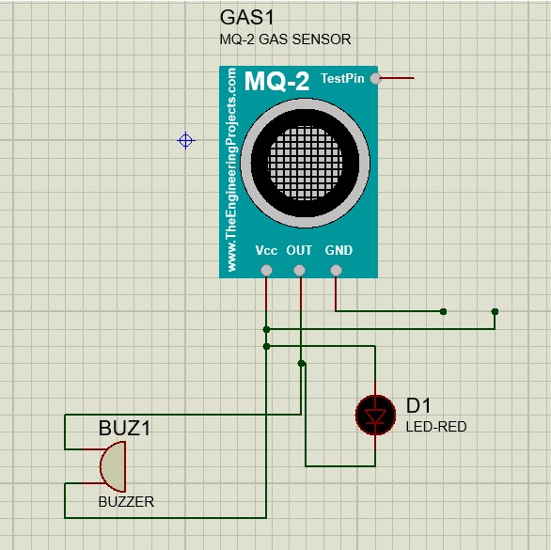

# Steps of Circuit Completion

1.Made all the connections properly.

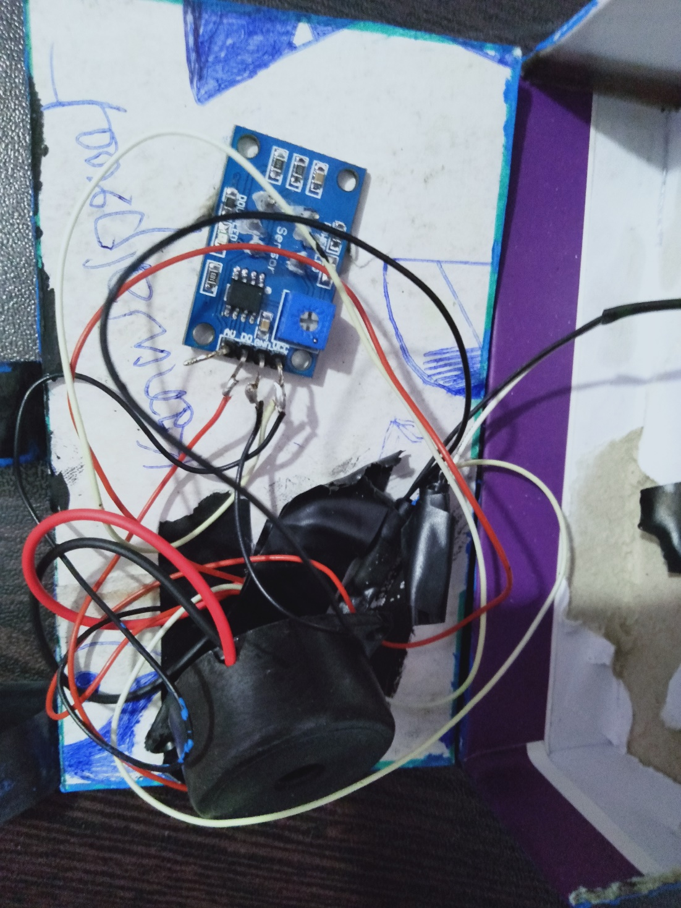

2.After completion.

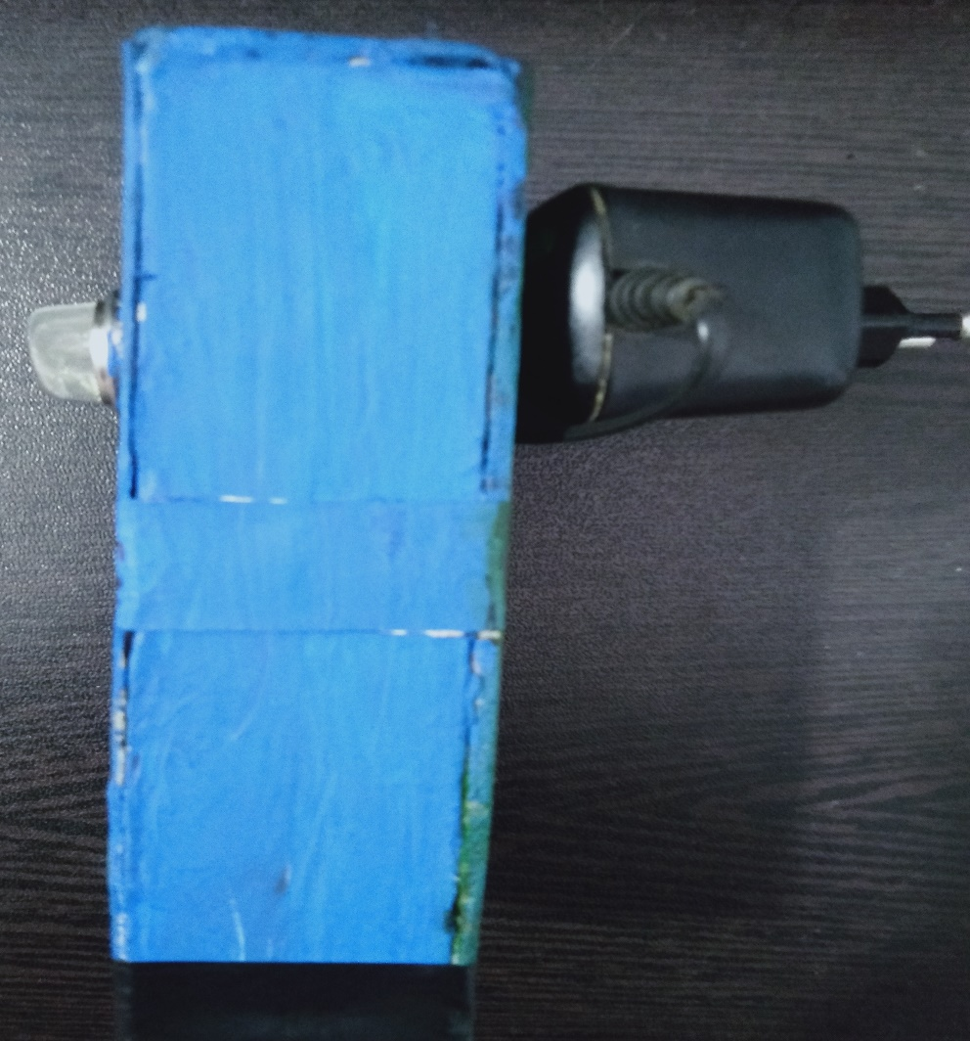

# 

# Program Code

(No Code)

**Project link:**